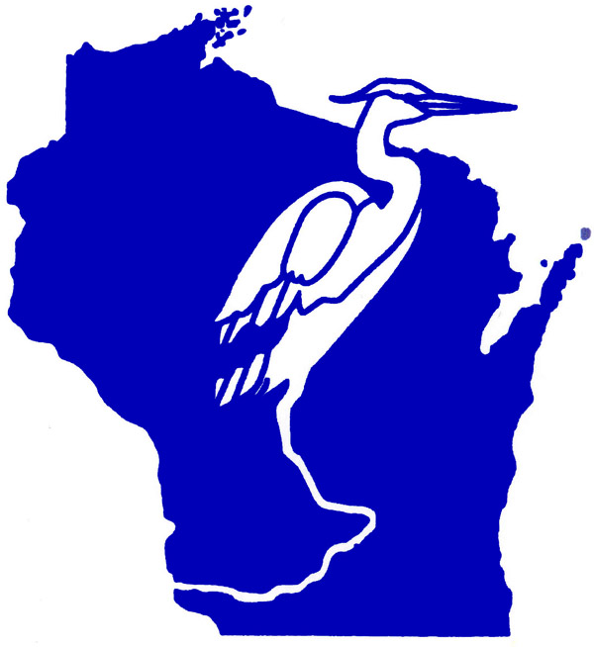
Lower Wisconsin
State Riverway Board
202 N. Wisconsin Avenue ∙ PO Box 187 ∙ Muscoda, WI 53573
(608) 739-3188 ∙ 1-800-221-3792 ∙ FAX (608) 739-4263
Email to: mark.cupp@wisconsin.gov
Web site: http://lwr.state.wi.us

NOTICE OF PUBLIC MEETING

NOTICE IS GIVEN that matters concerning Riverway issues or the Lower Wisconsin State Riverway Board's program responsibilities or operations specified in the Wisconsin Statutes, which are not on the agenda, may be acted upon if the Lower Wisconsin State Riverway Board determines it is urgent to act. Such matters may be raised as the result of discussions under agenda items: Committee Reports, Other Business and Executive Director's Report.

The Lower Wisconsin State Riverway Board (LWSRB) Executive Committee will meet on Monday, July 29, 2024, beginning at 4:00 p.m. The meeting will be conducted via Zoom conference call. For call in information, please see below. The purpose of the meeting shall be to discuss correspondence and other business requiring committee approval. Persons wishing to participate in the July 29, 2024, Executive Committee meeting may join the Zoom conference call. The agenda for the meeting is listed below.

AGENDA

- Call to order
- Acknowledgment of public meeting notice
- Correspondence
- Other business
- Adjournment

For further information regarding the July 29th meeting of the LWSRB Executive Committee, contact Mark E. Cupp, Executive Director, Lower Wisconsin State Riverway Board at (608) 739-3188 or by e-mail at mark.cupp@wisconsin.gov.

END
Join Zoom Meeting
https://us02web.zoom.us/j/83667828848?pwd=6dIUbFbXO4pQ5aaWDfa4Gt6WFrv58c.1

Meeting ID: 836 6782 8848
Passcode: LWSRB

Or to dial in by phone:
1-312-626-6799
Passcode: 250763

